Food Waste
We are thinking about how we can reduce the amount of food that we throw away.

This is what we thought:
Put less food on our plate
Only take what we can eat
Use all of the food we buy within the date
Use the food waste in some other way

Some food always has to be thrown away. Each class has a brown bin to put our food waste into. The resource monitors empty the bins and clean them out. The apple cores, banana skins, orange peel etc. are taken to be used as compost to grow more food!

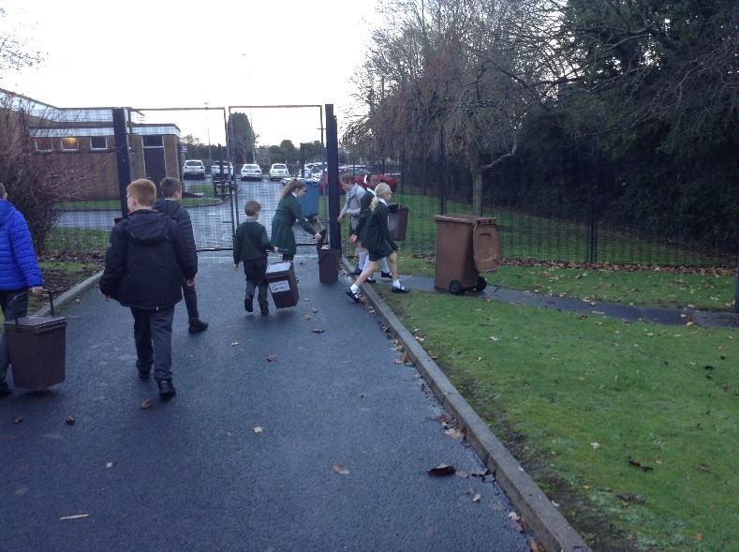

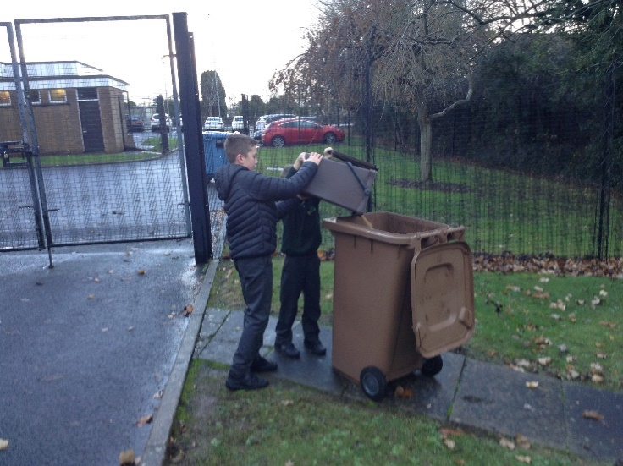
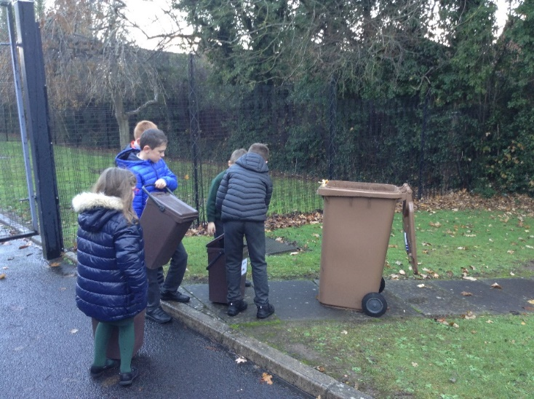

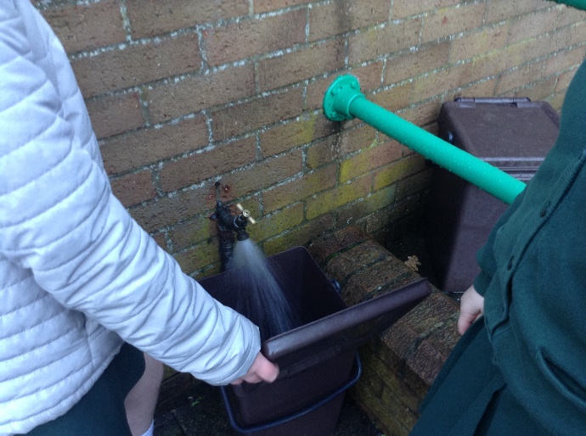

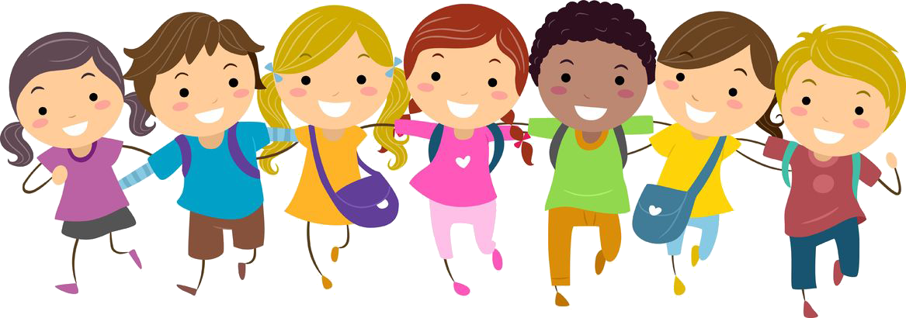
This Photo by Unknown Author is licensed under CC BY-NC

Sustainable Travel
There are more cars on our roads than ever before and this means that more gases are being released into the atmosphere. We are part of a scheme that encourages everyone to either walk, scoot or cycle to school instead of going by car. This means we could reduce the level of air pollution.
We try to walk to school and we have days when we meet at a place close to school and all walk together to try to encourage more people to walk. When this happens during the dark mornings we call it “Ditch the Dark day.” As you can see we all try to wear brightly coloured clothes, reflectors or high visibility vests! This is great fun and we love walking together we have more time to chat to our friends!!!!

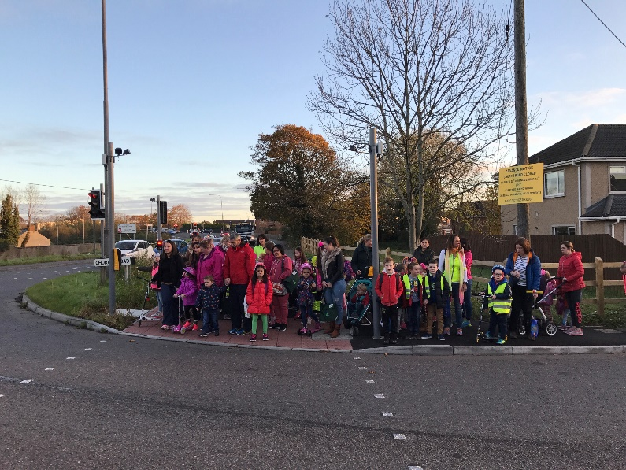
We also learn about how to keep ourselves safe near the roads. Dave comes and teaches about how we can make ourselves seen by drivers and other road users.
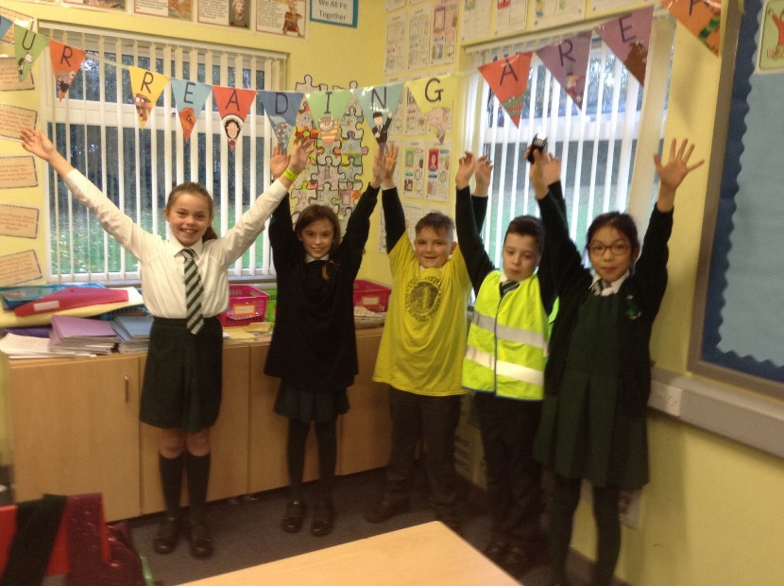

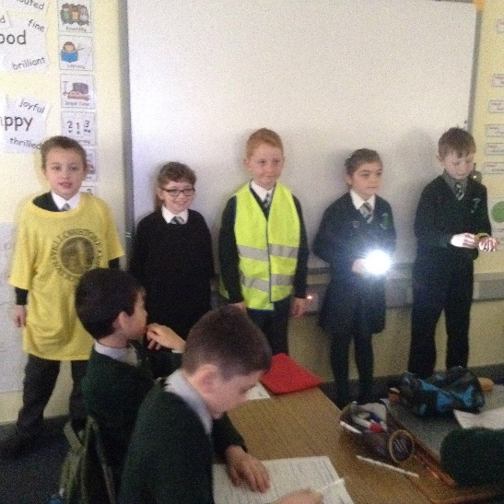

We ran competitions throughout the year to see which class were the best walkers, cyclists and scooters!
The Primary Seven class took part in the cycling proficiency scheme. This includes learning about your bike and how to keep it in good condition for cycling on the roads. They also had to learn part of the highway code (the rules of the road) and hand signals to show other drivers when they wanted to turn or were slowing down. This is a difficult course and they needed to practise a lot!

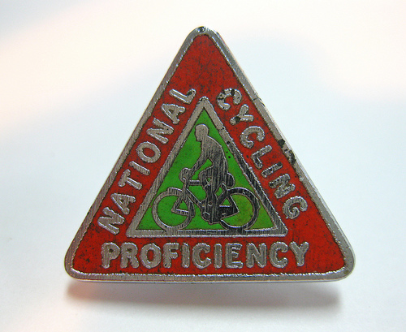
This Photo by Unknown Author is licensed under CC BY-SA

